Author’s name  Kumar, Apurva  Business unit  Customer Service  Management  Implementation Approval  Brenton Haskard  Field NBN and Products Manager  E2E Assurance Team | Sub-business unit  Field Service Delivery  Issue date  14 June 2018 | Issue number  15  Telstra ID  AOM-0161  Process Owner  Shadi Abouhaila  GM E2E Assurance Process  E2E Assurance Process

Summary
This document is to be used as the National process by all Communications Technicians (CTs) the work instruction will outline the Assurance steps for Identifying & Resolving a DOT Broadband or TBiz Voice service, over the NBN carriage way.
The Netgear v7610 is currently the only Telstra Business Smart Modem available for DOT on FTTN/B
DEVG2020 and V7610 are used for DOT on ADSL, DOT on FTTP


Purpose
This document covers the field workforce activation steps for DOT Broadband and T-Biz Voice products using NBN carriage.
Note that TBiz Voice is a Digital Office Technology product without the Internet data; this is a calling product only. Unless specified otherwise the term “DOT (Digital Office Technology)” refers to both products.
This work instruction outlines the steps for
Identifying a DOT Broadband Assurance task
Identifying and Testing the NBN network at site
DOT Broadband escalation process
Installing, configuring and commissioning a Netgear DEVG2020.

Scope
Any DOT Broadband service, which has value added products and is connected on the NBN carriageway.
This document is to be used as a National field process by all Field staff engaged in DOT Broadband NBN Service Calls and should be used in conjunction with but not limited to the following work instructions and support information
For information on configuring the DEVG2020 please refer to 002419w02

For more information on DOT Clip-On’s refer to 005347w15

For more information on DOT Activation refer to 005347w18

http://www.in.telstra.com.au/ism/fieldessentials/digitalbusiness.asp

http://www.telstra.com.au/business-enterprise/bundles/telstra-digital-business/support/index.htm

The Service Delivery field workforce is committed to ensuring we deliver Digital Office Technology Broadband customers the expectations around the products and services they’re receiving, we will ensure we meet and exceed the customer’s expectations and provide them with a WOW experience.



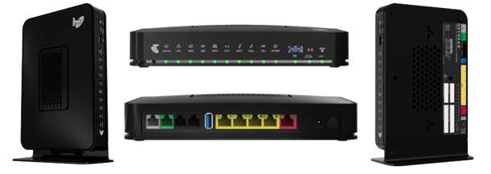
Contact Numbers

Important: Some of the contact numbers below are “in-house use only” and are not to be provided to Customers.
Contact | Telephone | Description of Function
CT Help Desk | 1800 634 640  Option 3 | Assist CT’s by removing issues preventing a TOW from being completed. CT Helpdesk can now help with most DOT Activation issues. For Example:  Organise replacements for activation DoA router & handset CPE  Rescheduling of installation appointment  Back to Base alarm issues  Cust data password reset  Process Support  Troubleshooting  User name/password  Setup Advice  SCA setup (analogue)  Fax & EFTPOS support  Line Hunt Set up, organise creation if missing  Support for non standard install
Wireline Activation  (WA) | 1800 215 835 | Contact the WA (for Activation TOWs) :  If the Config Summary is not available via Toolkit or Auto Router  If there is any information missing in Config Summary  MBB issues/Next G Failover Pin
NBN Business Assurance FOH | 1800 291 033  (Business)  1800 087 208 (GES) | First in support for NBN Business TOW assurance, manage fault TOW, raise nbn co trouble tickets.  These numbers are for Field Technicians Only.
Telstra PLUS | 1300 723 572 | If the TOW has TELSTRA PLUS in the remarks contact T-Plus after the Router install/cabling and IP phones are installed. Telstra Plus will assist the customer with installation of PC/Printer/Servers and network applications either onsite or by phone.  T-Plus will also provide phone assistance to CTs for Router, LAN, printer, handset facilities queries and Auto attendant  If contacting T-Plus outside of Business Hours; SMS with relevant comments to 0488023984 or leave the order details on the T-Plus IVR
NTSC  (National Technical Support Centre) | 1800 032 502 | Provide support for CT’s needing technical assistance for all technology types including Digital Office Technology.
Digital Office Technology Customer Queries & Sales | 13 2000 | Customers can contact FoH for all Sales, Billing, Technical Support and Accounts queries; say “Digital Office Technology” “Sales” to the IVR prompts.  “Technical Support” can assist customers with Cust Data logins, Configuration Summaries and device usernames and passwords.
Business Internet Group (FoH) | CTs & Customer’s  1800 066 594  (BIG BoH  1300 304 792 only have limited access to DOT systems) | Assist with IP telephony (including analogue port and NextG failover) problems that are included in the order once NBN connectivity has been established  Re-send of the customer’s Configuration Summary to Customer’s or CT’s email  Assist with CustData and CallConductor/CommPilot credentials and device usernames/ passwords
Business Internet Group (Back of House) | 1300 304 792  1800 034 663  For Technician | For assistance with Business Assurance modem changes, such as obtaining customer credentials or moving from one type of CPE modem to a different type of CPE modem.
FOLDS  (Fax Online Diagnostic Service) | 1300 368 999 | Create and send a one page test fax to FOLDS and review return fax with performance analysis
TIPT Level 2 Support (Centre for TIPT assistance) | 1800 701 807 | TIPT Level 2 DOT Specialists can be contacted when on a fault ToW  (ask for TIPT Trained DOT and TIPT staff)
NEW  Telstra Business Service Centre (TBSC) Order Remediation & DOT Case Managers | NEW NBN Number  1800 051 763 | Will amend the service to provide Shared Call Appearance, for Fax, EFTPOS and in the following cases:  Provisioning errors – analogue not provisioned or provisioned incorrectly – can be done whilst CT is onsite with customer  Sales Errors - analogue omitted from the order but was originally requested by the customer (and it is essential for the customer to run their business) – may not be completed while CT is onsite; OR team will contact customer once done  If the customer did not request a needed analogue service at purchase they should contact their sales rep/TBC or contact 13 2000 (say Digital Office Technology Sales) following the completion of the install  Note: BIG manage faulty CPE requests for Assurance ToW
Resolution Summary
CT Action | Summary of requirements
Pick up ToW | Review the Customer details  Identify if issue is Modem or CPE related  Call On Approach
Survey Premises | Check NBN Co equipment is working  Check UNI-D port connected correctly to Modem  If Clip-On issue (Handset / Headset / IAD / Ethernet Switch then ensure it is plugged in and switched on correctly
Premises Wiring | Check / Modify premises cabling  FFS will apply
Configure Modem | Check configure modem using the Basic and Advance setting in GUI (if required)  GENIE / Wizard will only work after a Factory Reset
Clip-On Issues  (005347w15) | Use 005347w15 inconjuction with any Clip-On issue  Connect all Clip-On’s (IP Handsets / IAD)  Use DOT Summary information from Autorouter to load handset credentials  Confirm correct numbers are displaying
Test Device | Power Cycle Modem and Clip-On’s (if required)  Check Internet Connect on Computers  Check Clip-On’s are functioning correctly
Customer Session | Access the DOT site  When required show the Customer How To:  Make and Receive Calls  Use Hold / Transfer and Pick-Up options  Setup and Retrieve Voicemail  Access Codes Features  Use Analogue device functions  Use 005347w15 inconjuction for any Clip-On information
Completing ToW | Ensure the Customer has a working service  Process any FFS (if required)  Complete the ToW

NBN Co Equipment

NBN Co. offer different carriage types depending on the location of customer’s residence. Different equipment is installed at each depending on the network type.

Full details of all NBN Co Customer Equipment is available in 015657w08 NBN Customer Connection Equipment . This includes user guides, an explanation of the indicator lights and other CT or customer accessible functions. CTs will need to refer to this document is more information is required.

* Important Note – It is the responsibility of NBN Co to install, configure and maintain their equipment. Telstra CTs are not permitted to perform any works on the NTD or fibre distribution. Telstra CTs can only perform testing and interconnection from the NTD ports.

Testing the NTD and allocated UNI-D port
The procedure commences with you connecting your Computer to the allocated Uni-D port on the NTD and testing the service as follows:
Launch an Internet Browser session and attempt to browse a web site
TBiz Voice services will only be able to access the Telstra Business customer sites such as CommPilot, Cust data etc.
Browse to CommPilot https://ews.digitalbusiness.telstra.com/Login/

DOT Broadband services will allow you to browse the Internet if programmed correctly

Note: - If NBN Co equipment is installed but appears not to be working (e.g. Red Light on NTD) refer to NBN Co Equipment section in this document before calling Wireline Activations

Actions – Field CT Task
Log On to ToolKit
Use the comments and description codes on a Ticket Of Work to have an understand of what testing and analysis has been performed prior to you receiving the job.
It is important to take a few minutes and read through the TOW gathering those details to achieve an understanding of the customers Issue.
Below are some description codes, this may help give an indication of the fault
Service Plus Codes | Meaning
NSYN | ECO LED red
NNSY | WAN LED flashing
SPEE | Speed Related Issues
AUTH | IP address or email issue
NDAT | No IP Traffic (Sync OK)
DROP | Drop Outs (intermittent No Sync)
DOCT | CT Attendance Required (Device or CPE issue)
TOW will have the following remarks:-
DOT BROADBAND, NxxxxxR NUMBER
Customer’s USERNAME. Username’s are not case sensitive. (@direct.telstra.com)
Customer’s PASSWORD. Password’s are case sensitive.
Details of UDI and Voice Calling User Password
Check any instructions from the BIG group tester.
No Sync faults (NSYN or NNSY) should have details of the isolation testing being performed at a particular location.
SPEED related issues will advised what SPEED the customer is achieving and the customer planed speed.
Contact the Customer / C.O.A
Before arriving / selecting on site you will need to Contact the Customer on the provided contact number.
Advise the customer of your approximate arrival time.
Check if the Fault is still current and if the customer advises that fault has cleared, the service is working to their satisfaction then Onsite and Complete the task using clearance the quick clear code GN8NN if not then
Verify that there is an authorised representative over 18 years of age on the premises. If there is no authorised representative on the premises over 18 please refer to the current NIA process.
Confirm that the Modem is plugged into a power outlet and switched ON
Advise the Customer that you may be interrupting the service while you perform the required testing work, calls to the main number can be diverted to the nominated mobile service until the Modem issues are fixed.
Customer Not in Attendance (NIA) or under 18 yrs.
Onsite TOW.
Follow your normal NIA process
Leave a completed Telstra NIA card at the main entrance with the Business Internet Group’s (BIG) number 1800 066 594 so the customer can make another appointment.

Proving The Modem
For information on configuring the DEVG2020 please refer to 002419w02

Prove the connection to the Internet using your Computer and the customer’s modem. Connect your computer via Ethernet to the customer’s Modem, open an Internet browser and attempt to surf the internet (www.google.com) or if TBiz Voice then browse to CommPilot (https://ews.digitalbusiness.telstra.com/Login/)
If unable to connect to the site browse to the modem’s homepage at 192.168.15.1 and check the connection status.

If the connection status is ERROR “not connected” then the network is not connected and you have previously proven the NTD port then the modem must be faulty
When replacing the modem follow the ACTIVATION process 005347w18
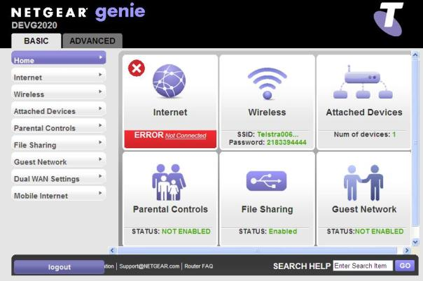

VOICE Calling Setup and UDI should be on the Assurance ToW and can also be found using the steps in Appendix 1 if required.

Speed Testing

Speed Testing is part of the NBN Install Checklist promise and also part of the Professional, Premium Professional and Complex Professional install plans. It is mandatory for all new installations.

It is important that you ascertain that the service is performing to the minimum specifications set out by nbnTM for the end users particular carriage, and advise the customer that their service is performing to within those specifications.

It is important that you demonstrate to the customer the actual speed results measured via an Ethernet connection.

IMPORTANT You will not need or be able to perform a speed test on a T-Biz Voice Service as it does not have Internet Browsing facility.

It is important that you ascertain that the service is performing to the minimum specifications set out by nbnTM for the end users particular carriage, and advise the customer that their service is performing to within those specifications.

You must perform the speed test using http://speedtest.telstra.com with your Toughbook connected via Ethernet to the Telstra CPE. Speed testing via Wi-Fi is not a valid test due to the many variables that effect Wi-Fi signals.

Access your internet browser and type in web page
http://speedtest.telstra.com
Click on the nearest capital city, the test will automatically start.
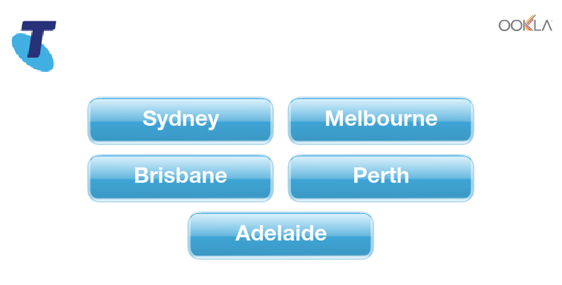

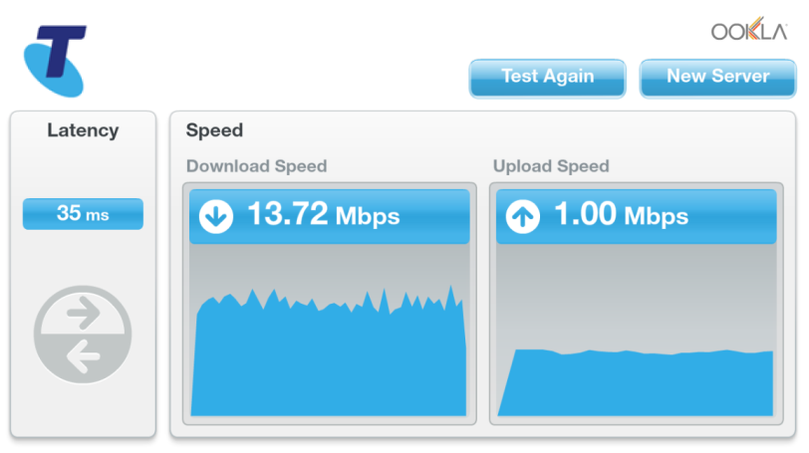
When the test has concluded, check that you have obtained at least 80% of plan speed.

nbnTM MTM carriage, minimum speed guideline
Activation– 80% of plan speed
Assurance– 80% of plan speed

IMPORTANT: If the service does not test within benchmark parameters escalate to Wireline Activation.

Faulty Modem Replacement

Note: - Faulty modems due to fair wear and tear are replaced free of charge for PA and Voice only customers (single line only) whether they are in or out of warranty

Customers who have a maintenance agreement

NO FFS applies
Fair wear and tear – replace with van stock

FFS DOES apply (Incorrect callout: ICO + Modem cost + Additional labour if required)
Lightning Damage (for PA and Voice only customers, FFS to be charged for cost of modem only, i.e. no ICO applicable)
Physical/malicious damage

Customers who DON’T have a maintenance agreement

NO FFS applies
Fair wear and tear – PA and Voice only customers (single line only)

FFS DOES apply (Incorrect callout: ICO + Modem cost + Additional labour if required)
Fair wear and tear
Lightning Damage (for PA and Voice only customers, FFS to be charged for cost of modem only, i.e. no ICO applicable)
Physical/malicious damage

For lightning damaged modems, the customer has the option of claiming the costs through their contents insurance. This also applies for any other natural disaster as well, including flood, fire, etc.

All faulty modems should be returned following the faulty material returns process

Contact BIG BOH to assist with Telstra Modem credentials and/or to change from one type of CPE to another.

Service Appointment Fee
Telstra have introduced a charge for all Business NBN related in home faults where our customers choose not to participate in remote troubleshooting.
Assurance will advise the customer that we cannot investigate the fault further without an onsite visit, which they will be charged for. This charge will be applied and the Technician will have no option to prevent the charge.

When Assurance advise the customer of the charge ($135 for visit and 30 minutes, and increments of $40 per 15 minutes thereafter where issue is in customer’s private equipment), the customer will be given the option to reconsider and participate in troubleshooting.
Some customers will be exempt from charging, these include customers that are PA or customers who have in-contract services, or are physically unable to perform the requested tasks.

How to identify these Tickets of Work,

Any Business NBN fault with the Service Appointment Fee applied with have “Service Call Fee Applied” stamped in the Result of Test notes.

The fee covers getting the CT on site to perform the required troubleshooting. Once on site the CT works as normal and either repairs the fault, proves the issue is in nbn co’s network, or proves the issue into the customer private equipment or cabling.

No matter the outcome of the fault visit, the fee is charged.

Where the issue is in the customer private equipment and the customer elects for the CT to continue the repair then additional FFS 15 minute increments can be charged following normal process.

An incorrect callout (ICO) fee does not apply when a service appointment fee has been charged.

Problems preventing completion on the day
If a TOW cannot be completed on the day, the appointment should be rescheduled with the customer in conjunction with Delivery Management, and the TOW should be Incompleted, as per standard process.

Assurance - nbnTM network issue identified

CT actions required when a customers fault is proven to be in the Network side of the Network Boundary Point (NBP) and and needs to be referred to NBN.

Partial complete the order with Job Status “Change of Workforce” , use TANL as the clearance code, and provide a detailed completion remarks to advise why the fault needs to be sent to NBN.

For any Priority Assistance (PA) customers you must call 1800 291 033 to organise an interim and to create the NBN Trouble TOW. (Then complete the order as in step above)

A phone call to NBN FOH Testers is no longer required and by following the aboves steps you are no longer required to include the NBN Trouble Ticket number in your completion remarks.

DOT CPE Assurance issue
For assistance with device related issues on a Assurance task you should contact the NTSC Helpdesk who will help resolve the issue or
Escalate to a local Subject Matter Expert (SME) if required.
If NTSC is not available, contact your local Subject Matter Expert (SME).

Responsibilities
The CT is responsible for the following actions
All “Incomplete” TOW must follow Regional Incomplete Procedures
BIG must be kept informed of Repair Progress and Incompletion arrangements
All customer information must be managed within the Telstra Privacy Policy
CT must meet Code of Conduct policy guidelines

Measures
CT’s are measured on their ADSL performance in line with the standard fix & fit performance guidelines.

Configuration of the Netgear DEVG2020

For information on configuring the DEVG2020 please refer to 002419w02

The Netgear DEVG2020 can be configured in 2 ways after accessing the GUI (Graphical User Interface) either via the initial setup wizard (GENIE) or manual setup.

When the Netgear DEVG2020 is first accessed via the GUI, either out of the box or after factory default, you will be presented with a setup wizard (GENIE) if it has been previously configured you will be presented with the login screen.

For a NBN connection connect from the WAN port on the back of the Netgear DEVG2020 to the allocated UNI-D port of the NTD

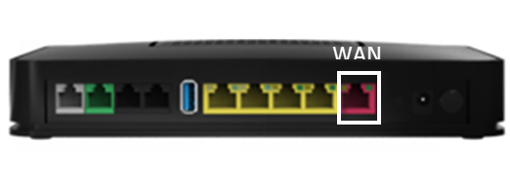

Initial Setup via Genie / Wizard
The GUI can be accessed by either Ethernet or wireless with the Telstra default IP address 192.168.15.1 . Browsing to this IP address will start the installation wizard which will firstly determine the WAN interface is being used.

You will now need to select which options you want to configure. You must tick the Setup Voice Calling option for all DOT installations but it is not necessary to setup any of the other options unless the customer would also like to customize the Wi-Fi settings and/or Admin password. These options can also be changed later via the GUI if required.

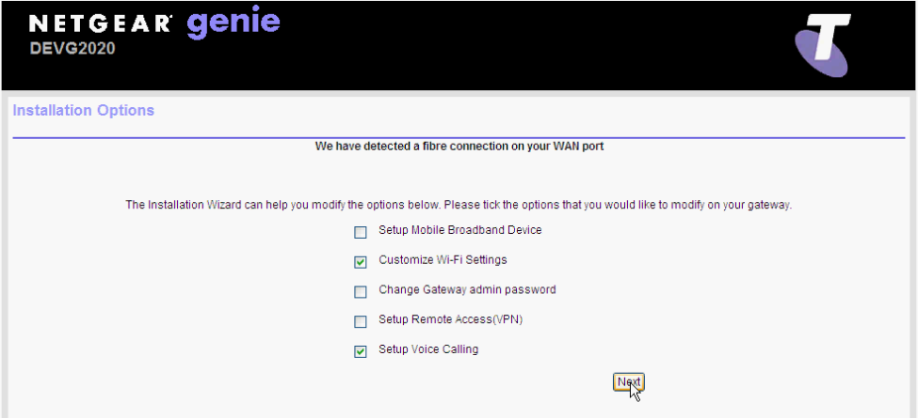
Click Next

Once the Modem receives its nominated IP address the other option that you have selected to modify from the Genie / Wizard will become available like WiFi and SIP setup completion will then follow the wizard instructions through to the final summary screen.

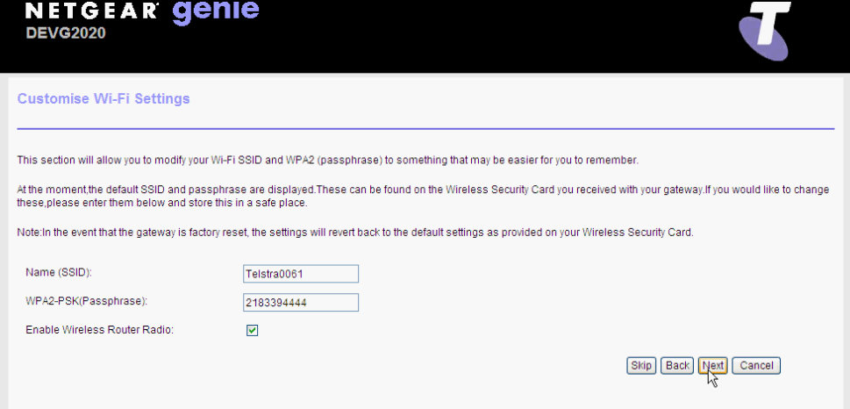
Setup the WiFi and select NEXT

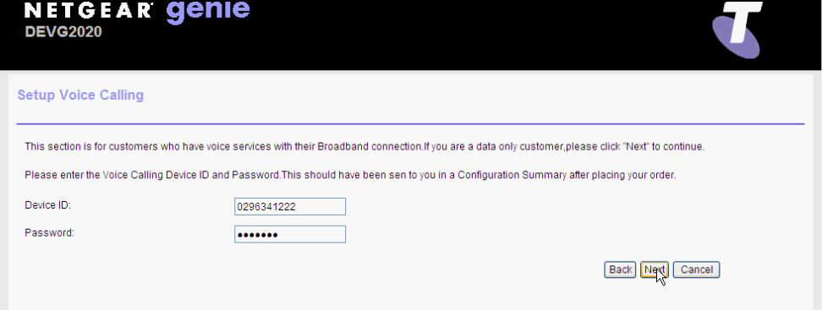
Setup the Voice Calling and select NEXT

You now will see a summary of the setup review and ensure the information is correct.
The changes you are about to make will now configure the modem which could include voice setup (if applicable) this will now downloaded to the modem.

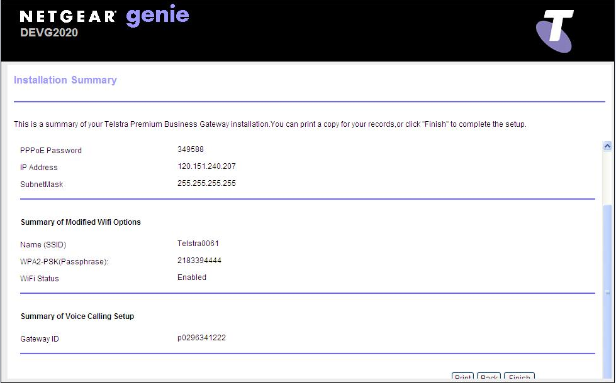

Select FINISH to finalise your request

When complete you will be presented with the Telstra Business Webpage.

http://www.telstra.com.au/business-enterprise/index.htm
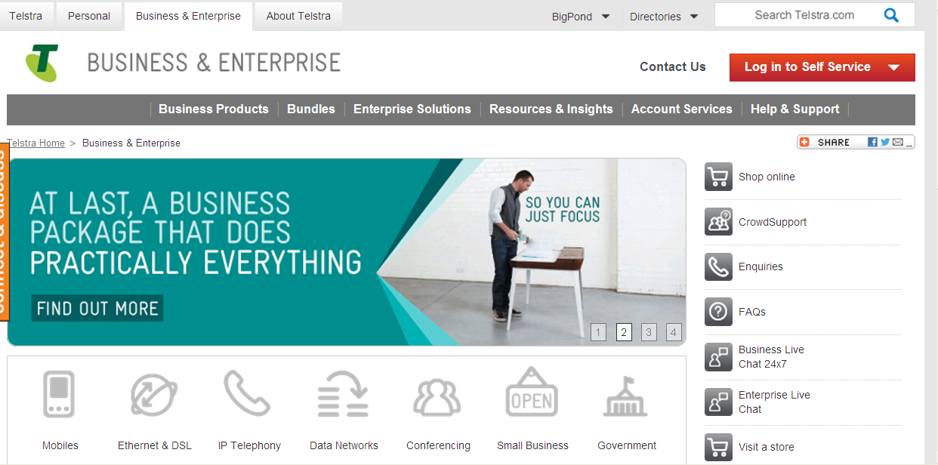

GUI (Graphical User Interface)
The GUI can be accessed by either Ethernet or wireless with the Telstra default IP address 192.168.15.1 this will bring up the below LOGIN screen and from here you will be able to configure the Netgear DEVG2020 to meet the customer’s requirements

To access the GUI you need to login using the default credentials of:

Username: admin Password: telstra

Click Continue

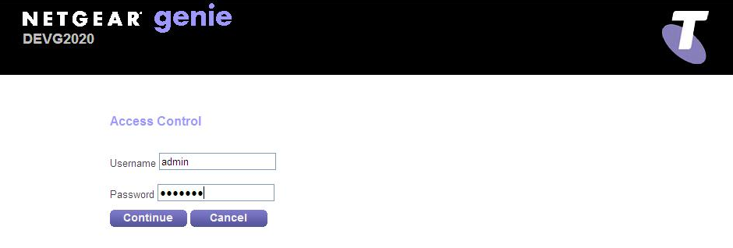
There are 2 main menus

Basic
Advanced

From each of these menus you will be able to view sub-menus which will indicate current details and also give you the ability to configure changes where appropriated to achieve the customer’s requirements.

Reconfiguring WLAN on the Netgear DEVG2020

The Netgear DEVG2020 Modem allows you to reconfigure the WLAN when require / requested. The following information will enable you to configure the Modem to suit existing CPE (i.e. Computers / Tablets)

The Netgear DEVG2020 is a Wi-Fi 802.11n device (2 Receive x 2 Transmit channels) with backward compatibility for 802.11 b/g if required;
For information on configuring the DEVG2020 please refer to 002419w02

Wireless setup (GUI)

On the GUI there is the ability to Configure the wireless setup of the Netgear DEVG2020 To access this go to 192.168.15.1 and:-
Basic>Wireless:
This gives you the ability to:-
Change the SSID (Modems name)
Enable / Disable SSID Broadcast
Change the Channel (other devices can use the 2.4GHz frequency so this may need to be changed if the customer is having wireless issues)
Change Encryption Key (10 character Alpha numeric preferred)
Change Security Settings (WPA TKIP preferred)
Note: It may be more productive to change the above setting in the Netgear DEVG2020 to match those of the device you are replacing than change all the WiFi devices in the premises.

To configuration the Main WLAN you will need to make any changes that may be required then once finished click Apply at the top of the screen
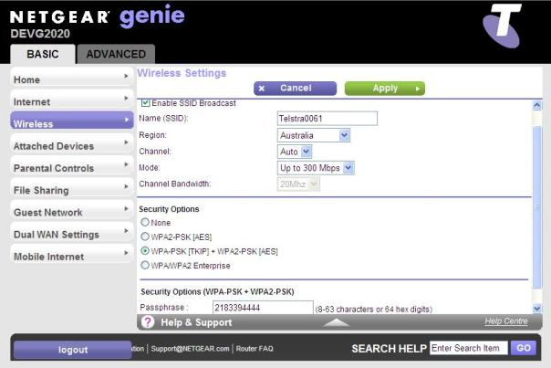

LAN IP Pool / DHCP Change

The Netgear DEVG2020 Modem allows you to reconfigure the LAN IP pool when require / requested. The following information will enable you to configure the Modem to suit existing CPE (i.e. Computers / Tablets) connected on a complex network rather than reprogram all the devices to the new Modem’s IP range.

If a customer has an existing LAN IP range that does not match that of the Modem’s default LAN IP pool (192.168.15.1) the following will need to be completed to identify the required LAN IP range
For Windows computers - access a command prompt and type in ipconfig and press enter.
For Apple computers - access the “System Preferences” select “Network”.
Select the appropriate port e.g. (Ethernet / Airport) Click “Advanced” and then the “TCP/IP” tab. The number next to "Router" is your current default modem.

Once you have the current or new LAN IP address to be used by the customer you are ready to start programming the new details into the Modem. Follow these steps to change the LAN IP pool it in the Modem.
Remember to have the Carriageway connected if possible
Step 1: Connect your ToughBook or a standalone computer to the Modem via an Ethernet connection and log onto the Modem GUI 192.168.15.1 homepage.
Step 2: Advanced> Setup > LAN Setup
Step 3: Under LAN TCP/IP Setup change the IP Address/IP Subnet Mask to the new details.
Step 4: The DHCP starting & ending IP addresses may also be changed if necessary.
Step 5: On the pop up click ok to reboot.

After the modem has rebooted you can log back into the GUI using the new IP address.

Note: Resetting the Netgear DEVG2020 to factory default or re-running the setup wizard will revert these settings back to default.

For information on configuring the DEVG2020 please refer to 002419w02

Configuring the NextG

A backup solutions is now available that provide an alternative path if the NBN carriage is down.
It is now possible to switch to 3G / 4G mobile access technologies such as GPRS, UMTS, HSDPA, HSUPA, HSPA+, WIMAX and LTE when the internet connectivity is not available via the main WAN connection. Simply by plugging a mobile USB adapter into one of the USB ports of the Netgear DEVG2020, IP connectivity via a 2G / 3G / 4G networks becomes possible. This will give the customer continuous service while there main connection is investigated and resolved.
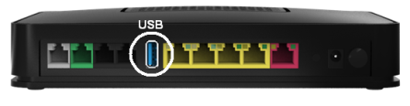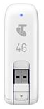
Note: Huawei USB dongle is NOT backward compatible with the DEVG2020 and ONLY works with the Netgear v7610.

To access the GUI and configure the Mobile Broadband device follow
Basic> Mobile Internet
Select the correct APN for your device then click Apply.

Note: The SIM is PIN protected to ensure it’s only used in the DEVG2020 there is no option to verify the PIN within the GUI, the PIN is included in the configuration downloaded to the DEVG2020 from the DOT DMS.

If the mobile device has a connection error the PIN maybe configured incorrectly in
CommPilot (ring CT HD) or the configuration download failed, please verify the Voice Setup
Device ID username and password and power reset the router to prompt for a new config download.
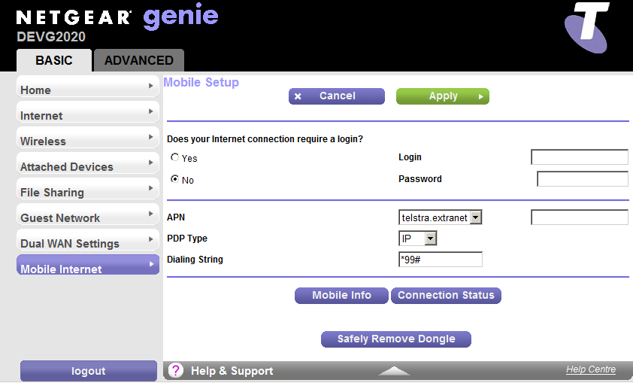
To check that the device has installed click Mobile Info and a window will pop up showing the signal strength, click Close Window.

To test the backup device unplug the ADSL line from the modem and to check that the mobile device has connected click Connection Status and ensure the Mobile Connection Status shows an IP address assigned, click Close Window, also check that you can surf before plugging the ADSL back in.

Note: The customer maybe using their own backup device the settings shown above are for a backup device supplied as part of the DOT package.

Resetting the Netgear DEVG2020 to Factory Default

You may on occasion need to complete a factory reset or if returning a faulty Netgear DEVG2020 to remove all customer details before removing the power complete factory reset the below show how easy this is (you will need a paper clip or pin)
You can also achieve the same result through the GUI
Advanced>Administration>Backup Settings click Erase

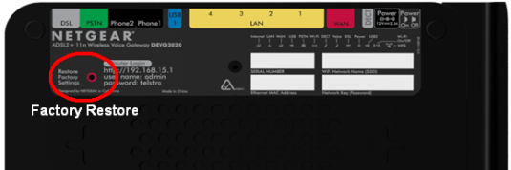

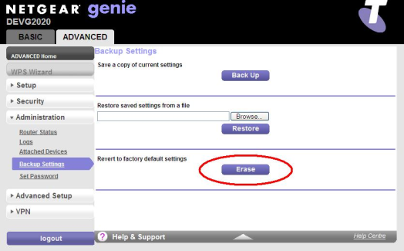

Appendix 2

DOT Feature Access Codes
*15 |  | Call Bridge
*72 |  | Call Forwarding Always Activation
*73 |  | Call Forwarding Always Deactivation
*21* |  | Call Forwarding Always Interrogation
*21 |  | Call Forwarding Always To Voice Mail Activation
#21 |  | Call Forwarding Always To Voice Mail Deactivation
*90 |  | Call Forwarding Busy Activation
*91 |  | Call Forwarding Busy Deactivation
*67* |  | Call Forwarding Busy Interrogation
*40 |  | Call Forwarding Busy To Voice Mail Activation
#40 |  | Call Forwarding Busy To Voice Mail Deactivation
*92 |  | Call Forwarding No Answer Activation
*93 |  | Call Forwarding No Answer Deactivation
*61* |  | Call Forwarding No Answer Interrogation
*41 |  | Call Forwarding No Answer To Voice Mail Activation
#41 |  | Call Forwarding No Answer To Voice Mail Deactivation
*94 |  | Call Forwarding Not Reachable Activation
*95 |  | Call Forwarding Not Reachable Deactivation
*63* |  | Call Forwarding Not Reachable Interrogation
*67 |  | Calling Line ID Delivery Blocking per Call
*31 |  | Calling Line ID Delivery Blocking Persistent Activation
#31 |  | Calling Line ID Delivery Blocking Persistent Deactivation
*65 |  | Calling Line ID Delivery per Call
*11 |  | Call Retrieve
*69 |  | Call Return
#92 |  | Call Return Number Deletion
*43 |  | Call Waiting Persistent Activation
#43 |  | Call Waiting Persistent Deactivation
*70 |  | Cancel Call Waiting
*99 |  | Clear Voice Message Waiting Indicator
*57 |  | Customer Originated Trace
*55 |  | Direct Voice Mail Transfer
*22 |  | Flash Call Hold
*12 |  | Location Control Activation
*13 |  | Location Control Deactivation
*60 |  | Music On Hold Per-Call Deactivation
*610 |  | No Answer Timer
*86 |  | Voice Mail Retrieval
*62 |  | Voice Portal Access

Appendix 3
Accessing CommPilot
More detailed information regarding the use of CommPilot can be found in this document:
005347w21 Call Management Tools (CommPilot CommManager CallConductor) For DOT

CommPilot is a DOT tool that enables customers to manage their DOT phone calls.
DOT tools (including CommPilot) can be accessed at the following hyperlink.
http://www.telstra.com.au/business-enterprise/bundles/telstra-digital-business/support/index.htm
Or
Directly logon to CommPilot https://ews.digitalbusiness.telstra.com/Login/

Enter the customer’s User ID and Password.
Click the Login button. The Profile page will display.
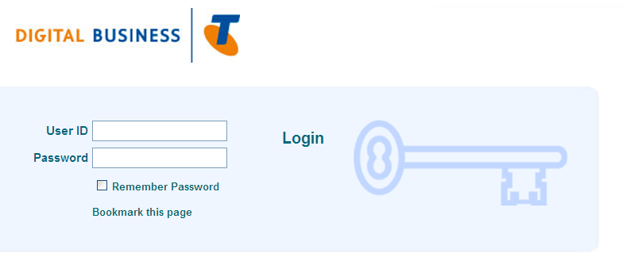

(CommPilot DOT Login Page)

There are 2 levels of access Group and User level this will determine what is visible on
their Profile screen.
NOTE: Customer’s login details are included in the Configuration Summary email. If the login details do not work, contact 132000 and say, ‘Digital Office Technology’ when prompted.

Group access level enables the user to control the functions of the entire group. Updates made on a Group level affect all DOT phones.
User access level enables the user to control the functions of their assigned phone number. Updates made on a User level affect only the number allocated to the user.
Call Forwarding
Call Forwarding enables customers to automatically forward calls received by their DOT digital phone.
There are four kinds of call forwarding:
Always: Every call is automatically forwarded to the number you choose.
Busy: Calls are forwarded only when the phone being called is busy.
No Answer: Calls are forwarded after a certain number of rings.
Not Reachable: Calls are forwarded when the DOT phone is inactive or not accessible.
Use the following steps to customise Call Forwarding.
Click the Incoming Calls hyperlink in the Options menu.
Click the Call Forwarding Always hyperlink.
Look at the options and fields on this page.

Ring Reminder forces the DOT phone to ring once before the call is forwarded. This provides a reminder that Call Forwarding Always is activated. Ring Reminder is only
available for Call Forwarding Always. Look through the other Call Forwarding options (Busy, No Answer and Not Reachable) and compare the different settings before applying

Simultaneous Ring
Simultaneous Ring enables multiple phones to ring at the same time as your DOT phone. This function enables customers to receive calls on their DOT phone and up to 10 other numbers simultaneously.
Important
If Call Forward Always is turned On, Simultaneous Ring will not work
If one of the other phones enabled for Simultaneous Ring goes to Voicemail before the DOT phone, the message will be on that phone’s Voicemail system not in the DOT MessageBank (unless it is received by a DOT mobile phone).
Use the following steps to customise Simultaneous Ring.
Click the Incoming Calls hyperlink in the Options menu.
Click the Simultaneous Ring Personal hyperlink.
Look at the options and fields on this page.
Enter the phone numbers (including area codes) of up to ten phones to ring simultaneously in the Phone Number / SIP-URI fields.
Important: Do not enter spaces in the phone number.

Click the Apply button.
Click the OK button to save the changes. Simultaneous Ring will be active immediately.

Sequential Ring
Sequential Ring enables multiple phones to ring one after the other in a specific order.

Important If Call Forward Always is turned On, Sequential Ring will not work.
Use the following steps to customise Sequential Ring.
Click the Incoming Calls hyperlink in the Options menu.
Click the Sequential Ring hyperlink.
Look at the options and fields on this page.
The Use Base Location first check box enables the first Digital Phone to ring before starting the sequential ring process.
The Number of rings drop-down menus specifies the number of rings a phone will have before the next phone is tried.
The Enable caller to skip search process allows the caller to go directly to the MessageBank service.
Enter the phone numbers (including area codes) of up to ten phones to ring simultaneously in the Phone Number / SIP-URI fields.
Important: Do not enter spaces in the phone number.

Click the Apply button.
Click the OK button to save the changes. Simultaneous Ring will be active immediately.

Shared Call Appearance
Shared Call Appearance enables different Full National Numbers (FNNs) to appear on the same device on different lines. This function is only possible on Multi line handsets like the Cisco SPA504G Digital Phone.

Shared Call Appearance features include:
Allowing an incoming call to appear on up to five IP phones simultaneously
Calls may be answered using any one of the appearances
One location is set as the primary line and the copies are alternates
A call can originate from any appearance on behalf of the primary location
An incoming call will alert all appearances of that number but when it is answered it will appear as busy
Calls can be placed on hold from one location and retrieved from any other location.
Use the following steps to create a shared line in CommPilot.
Click the Profile menu and click the Users hyperlink. The Users search screen will display
Click the Search button and select the prime user of the handset to whom you want to apply Shared Call Appearance.

Click the Call Control menu.

Click the Shared Call Appearance hyperlink

Click the Add button.

Important: Select the Allow Call Retrieve from another location on all Shared Call Appearances. This enables the *11 Feature Access Code to retrieve the call from any of the customer’s phones on the DOT network.

Select the IP handset you want to copy from the Identity/Device Profile Name drop-down list.
Enter pxxxxxx1111_01@domain in the Line/Port field. (The 01 means it is the first time
Ensure the three check boxes (Enable this location, Allow Origination from this location and Allow Termination from this location) are selected.
Click the OK button.

The original Shared Call Appearance screen will display with the new record.
Click the Apply button.

Definitions

The following words, acronyms and abbreviations are referred to in this document.
Term | Definition
ADSL | Asymmetrical Digital Subscriber Line
BDSL | Business Digital Subscriber Line (Telstra product name)
BYO | Bring Your Own (modem/router/handset)
CommPilot | TIPT Management tool, interface for Broadworks tool.
CPE | Customer Premises Equipment
CustData | Telstra Business Customers’ personal account management website
DOA | Dead on Arrival
DNS | Dynamic Name Server
DSLAM | Digital Subscriber’s Line Access Multiplexer, typically refers to an ADSL concentrator
IAD | Integrated Access Device (Analogue PSTN to IP Telephony adaptor)
ISAM | Alcatel’s Intelligent Services Access Manager, a type of DSLAM
NGO | Next Generations Operations
NTSC | National Technical Support Centre
PoE | Power over Ethernet
QoS | Quality of Service, a packet or protocol priority mechanism
RMA | Return Material Advice
SAMxx | Standard Activation of Multitask, indicates a OneStep ToW
SHDSL | Symmetric High Bit Rate Digital Subscriber Line (loop)
TATS | TIPT Activation Tool Set
TIPT | Telstra IP Telephony
ToW | Ticket of Work, a job summary despatched to a SD CT
VLAN | Virtual Local Area Network, overlayed on physical LAN
TBSC | Telstra Business Support Centre
VPN | Virtual Private Network (can establish a secure PC to PC/Server link over the internet)
WAN | Wide Area Network (The ADSL interface of the Cisco 527w)
WLAN / WiFi | Wireless Local Area Network (The office side of the Cisco 527w)
XDM | Cross Domain Manager, configures DSLAM options

Materials List
Serial Item:- | Description:-
759 / 226 | Netgear DEVG2020
572/108  572/110  572/107  572/326  572/119  572/459 | Cord Patch 45 / 0.5m  Cord Patch 45 / 2m  Cord Patch 45 / 3m  Cord Patch 45 / 5m  Cord Patch 45 / 10m  Cable CAT5E UTP 4/0.51 Grey 305 mtrs

References
Document Number | Title
013426w03 | ADSL Field Diagnostic Guide
013426w05 | ADSL Level 2 Field Diagnostic Guide
002419w02 | For information on configuring the DEVG2020 please refer to 002419w02
005347w15 | For more information on DOT Clip-On’s refer to 005347w15
Telstra Business Web Tools | http://www.telstrabusiness.com/business/portal/online/site/mybusinessneeds/digitalbusinesstools.450014
On-Line DOT Support | http://www.telstra.com.au/business-enterprise/bundles/telstra-digital-business/support/index.htm

Document Control Sheet

Who to contact if you have any queries, questions, changes or concerns.

Name | Apurva Kumar
Position | Senior Business Specialist
Phone | (02) 8576 5424
Email | Apurva.Kumar@team.telstra.com

Name | Richard Fiveash
Position | Technical Specialist
Phone | 0419 256 743
Email | Richard.Fiveash@team.telstra.com

If you have a suggestion for improving this document or Technical request, please contact the person listed above.

Issue number | Issue date | Details on the change
1 | 18/02/2013 | Initial Issue
2 | 02/12/2013 | Updated to replace Bigpond.com speed test with speedtest.net
3 | 23/12/2013 | Updated to include UNI-D port battery backup
4 | 17/02/2014 | Included NBN Assurance interim Field Process change for NBN Co issues. Section 12. AK
5 | 06/08/2014 | Update to DOT, revised mobile backup section 15.5 and Spares Process section 9.2 (RF)
6 | 04/03/2016 | Removed interim CT process and updated 1800TFIBRE number/options. AK
7 | 21/11/2016 | Updated document with new support process for DOT AutoRouter Configuration Summary failures. AK
8 | 30/03/2017 | Change NBN Business FOH Assurance number and add BIG BOH numbers in section 3. BSH
9 | 18/05/2017 | Add Line Hunt and Auto attendant to section 3. BSH
10 | 24/06/2017 | Included NBN Assurance FOH number for GES customers. AK
11 | 12/07/2017 | Updated Speed Testing to 50% of plan, Removed NBN equipment section. DK
12 | 12/09/2017 | Updated name of document to reflect DOT on FTTP and FW. RM
13 | 20/03/2018 | Remove FW references due to delay in rollout. Remove redundant Autorouter section (appendix 1). Remove reference to Digital group team leaders holding hardware stores. Update Faulty Modem Replacement. RM
14 | 07/05/2018 | Add Assurance Service Appointment Fee, update speed testing to 80% of plan speed, change “Gateway” to “Modem” BSH
15 | 14/06/2018 | Add COW process for nbn network faults (section 12)..RM

This publication has been prepared and written by Telstra Corporation Limited (ABN 33 051 775 556), and is copyright. Other than for the purposes of and subject to the conditions prescribed under the Copyright Act, no part of it may in any form or by any means (electronic, mechanical, micro copying, photocopying, recording or otherwise) be reproduced, stored in a retrieval system or transmitted without prior written permission from the document controller. Product or company names are trademarks or registered trademarks of their respective holders.
Note for non-Telstra readers: The contents of this publication are subject to change without notice. All efforts have been made to ensure the accuracy of this publication. Notwithstanding, Telstra Corporation Limited does not assume responsibility for any errors nor for any consequences arising from any errors in this publication.

